ROMAN NOVOZHILOV  International Sales & Business Development | B2B Building Materials | Remote-ready  Benicàssim, Castellón, Spain | +34 605-650-553 | novorom@gmail.com | Open to Remote / US-based companies | 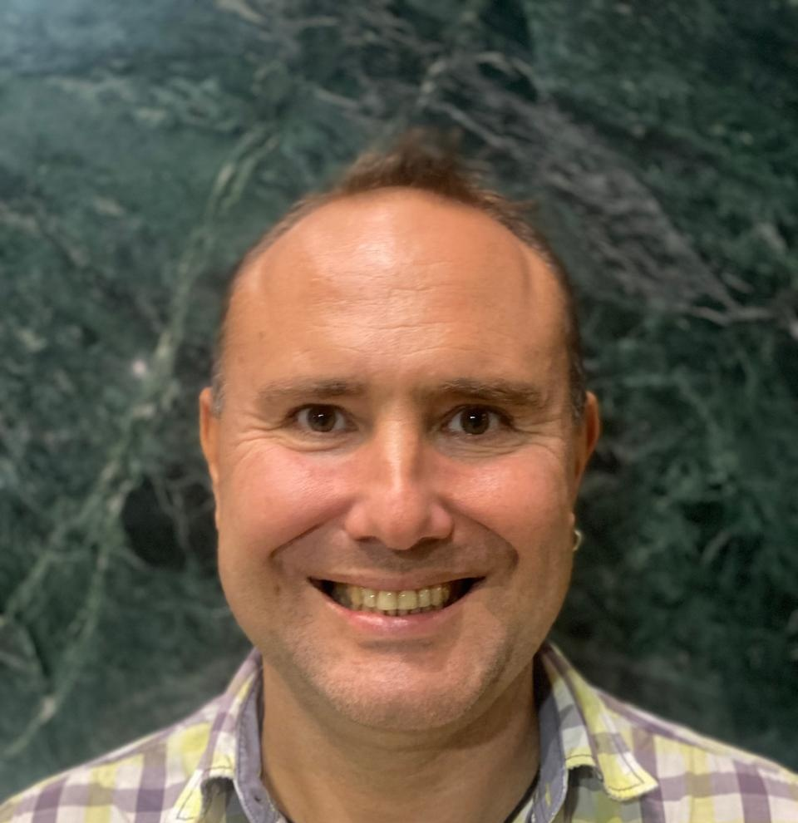

PROFILE
Engineer by education and sales professional by 20+ years of practice. Built and ran full-cycle B2B sales for ceramic tile and porcelain stoneware across Northwest Russia — from prospecting and contract negotiation to logistics, receivables, and long-term account management. Relocated to Spain in 2022 and now run independent e-commerce/web projects and automation pipelines for the same industry (plitki-spb.ru, cersanit-spb.ru, opt-plitki-spb.ru). Hands-on with AI coding tools (Claude, Windsurf, Devin, Codex) and GitHub Actions-based automation: Telegram news/digest channels, AI-generated video content across YouTube/TikTok/Instagram, and an email lead-generation/outreach system. Fluent in Russian and English (C1), conversational Spanish, comfortable working across cultures and time zones. Looking for remote roles in B2B/technical sales, business development, or sales engineering with US companies targeting Europe, Russia, or CIS markets.
CORE SKILLS
Sales: Full-cycle B2B sales, contract negotiation, key account management, distributor & retail network development, receivables management, market monitoring, exhibitions & trade shows, team training and supervision.
Industry: Ceramic tile & porcelain stoneware, building/construction materials — product knowledge, sourcing, supplier relations, logistics coordination.
Technical: Engineering degree (electronic systems); hands-on with e-commerce sites, Next.js/TypeScript projects, email automation (Google Sheets + SMTP), image/data pipelines (Python), GitHub Actions/CI-CD automation, Telegram Bot API, macOS.
AI Tools: Claude, Windsurf, Devin, Codex, OpenRouter — daily use for coding, automation, and productivity.
Languages: Russian (native), English (C1 — Advanced), Spanish (beginner).
EXPERIENCE
Owner / Operator — Independent E-commerce & Automation Projects — Freelance
October 2022 – Present · Benicàssim, Spain · Remote
- Building and running independent e-commerce projects for the ceramic tile industry: plitki-spb.ru, cersanit-spb.ru, and opt-plitki-spb.ru — product catalogs, automated image pipelines (Python + Cloudinary), and email marketing automation (GitHub Actions, Brevo SMTP, Google Sheets) to a 3,000+ contact database.
- Built and run 2 Telegram channels with automated news collection, translation, and digest generation, including a daily evening digest channel for emigrants.
- Built an automated AI video content pipeline distributing content across 2 YouTube channels, TikTok, and Instagram.
- Built an email lead-generation system that finds prospective client emails and sends automated outreach campaigns.
- All projects hosted on GitHub and run on GitHub Actions; hands-on use of AI coding tools (Claude, Windsurf, Devin, Codex) and a Next.js/TypeScript codebase.
Wholesale Manager — Ceramic Tile & Porcelain Stoneware — Independent / Home Office
June 2015 – January 2022 · 8 yrs 7 mos · Saint Petersburg & Northwest Russia
- Ran full sales cycle for major tile brands (Shakhtinskaya Plitka, Nefrit Ceramic, Kerabud, Azori, Kerama-Marazzi, Euro-Ceramic, Atem, Goldentile, Gracia-Ceramic, Ural Granit and others) across builders, distributors, and retail chains.
- Negotiated commercial terms: credit depth and limits, special conditions, penalty clauses, and contract structures; signed and managed distribution agreements.
- Managed accounts receivable end-to-end, including guarantee letters, reconciliation acts, shipment holds, and preparing claims for court when needed.
- Coordinated logistics, product matrix agreements, and in-store exhibition stands; ran marketing activities and promotions with retail partners.
- Represented the company at regional and federal construction trade shows; built and maintained long-term partner relationships.
Sales Manager — Ceramic Center (ceramic-center.ru)
December 2013 – June 2015 · 1 yr 7 mos · Saint Petersburg
- Sold ceramic tile and porcelain stoneware wholesale across the Northwest Russia dealer network, with regular business travel.
- Managed full negotiation cycle, contract terms, and product matrix agreements with distributors and retail chains.
- Handled receivables, claims, and reconciliation; monitored competitors and market conditions.
Regional Sales Manager — OOO Lincer (lincer.ru)
October 2006 – October 2013 · 7 yrs 1 mo · Saint Petersburg
- Built and managed the regional distributor and retail network for ceramic tile and porcelain stoneware across Northwest Russia.
- Owned commercial negotiations, contract signing, and product matrix placement with key accounts.
- Trained new sales staff and supervised in-store promoters; tracked shipment volumes, margins, and receivables turnover.
Head of Regional Office — Window to the World
January 2005 – June 2005 · 6 mos · Saint Petersburg / Volgograd
- Recruited and launched a regional partner office (Volgograd) to sell advertising space for the head office; evaluated partner capacity and negotiated the opening agreement.
- Trained the commercial team and liaised between the St. Petersburg head office and the new regional representation.
Regional Sales Manager — TD Pigment
September 2003 – March 2004 · 7 mos · Saint Petersburg
- Managed regional sales of paints; contributed to establishing business with Severstal.
EDUCATION
Saint Petersburg Electrotechnical University (LETI)
Engineer, Electronic Systems — 2004

